Huangguoshu National Park 110m Outdoor Large Music Dancing Water Fountains Show Project

Project description:
This project is located in Huangguoshu National Park, one of the AAAAA level scenic area in Guizhou province. Using modern sound, light and electricity, performance with laser, fire, gas explosion, one dimensional, three dimensional and DMX512 lights, the water spray height can be up to 100M. Combined with fountain is 90meters long water screen to show local Buyi culture and drama of "Journey to the West",extremely shocked when you be there,Huanggoushu welomes your kind visit.

Project Site：Huangguoshu National Park,Guizhou
Project Cost: RMB40,500,000
Project Period: January 2017
Project Stage: Accomplished
Project Content: Design, Production, Onsite Installation ,Programming and Debugging

Project Reference Photos:
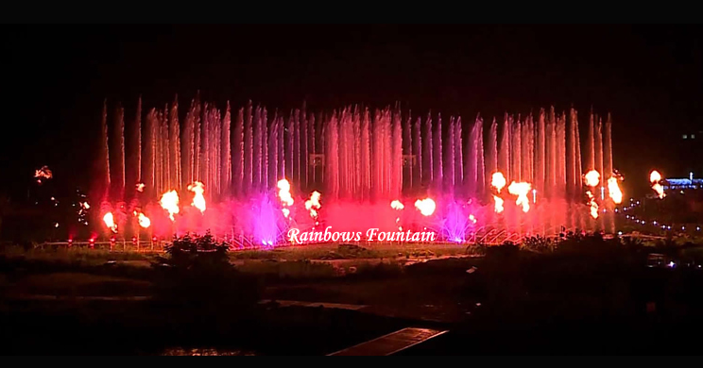
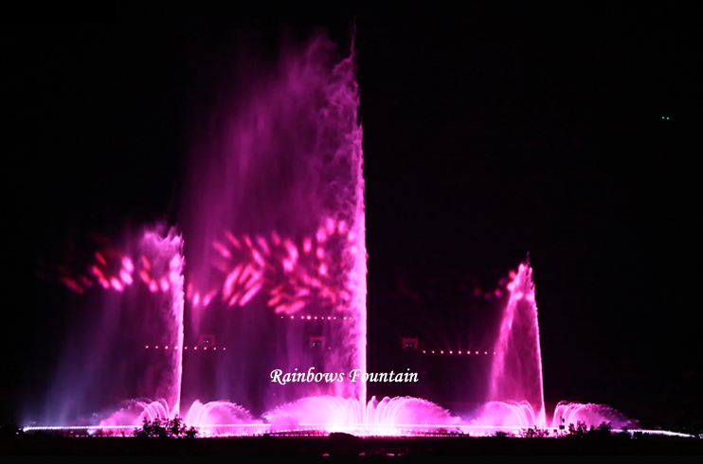
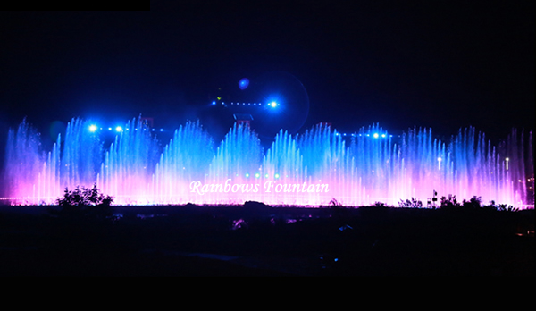
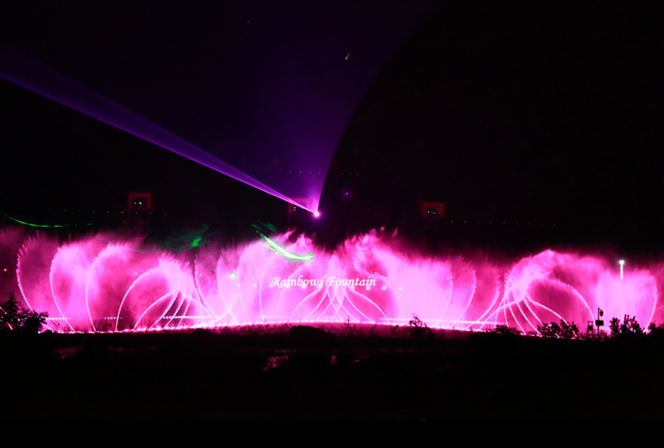

Fountain Design proposal and site situation
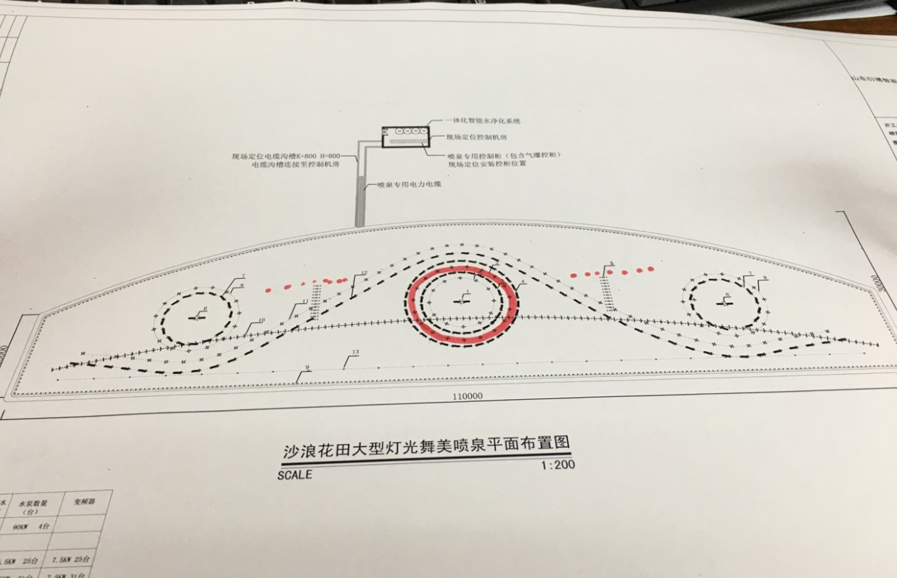
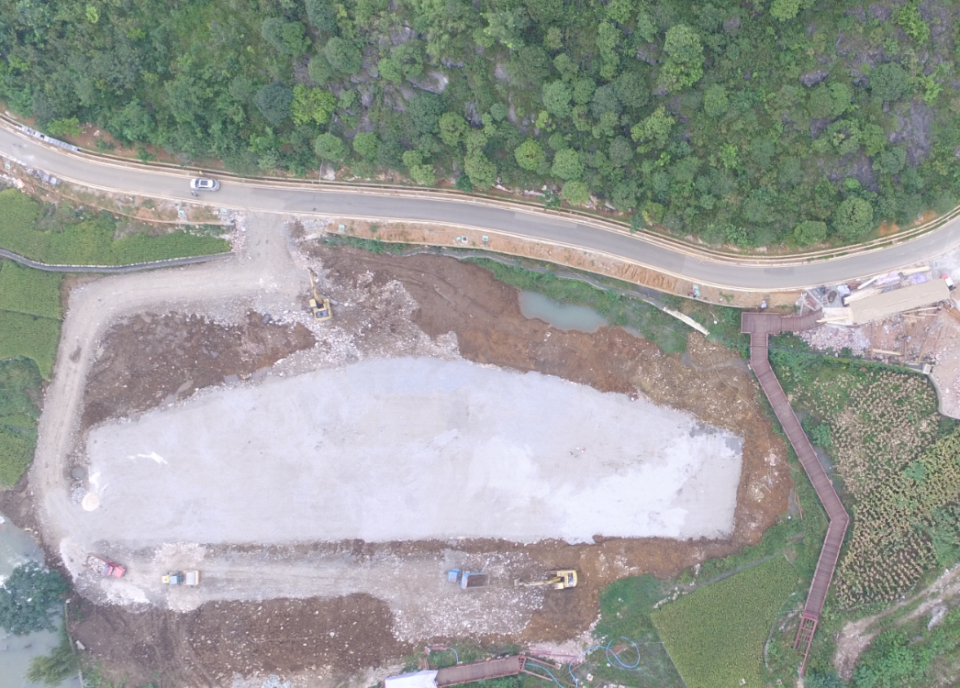

On site Installation and Commissioning
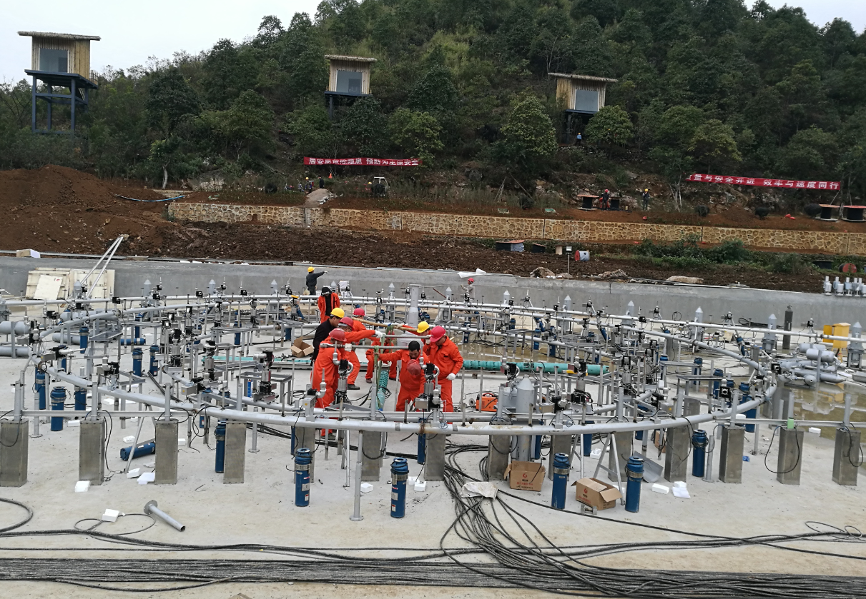
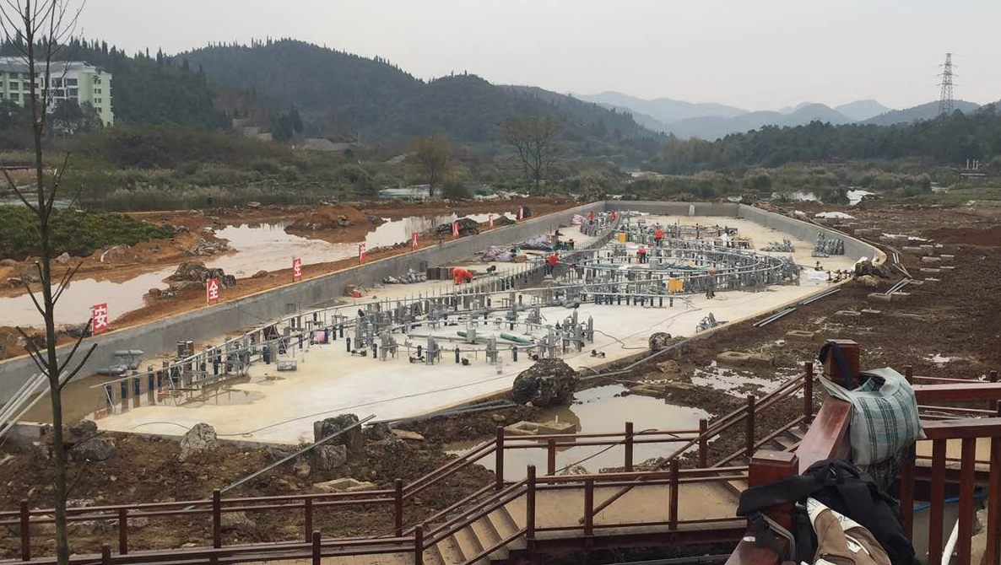
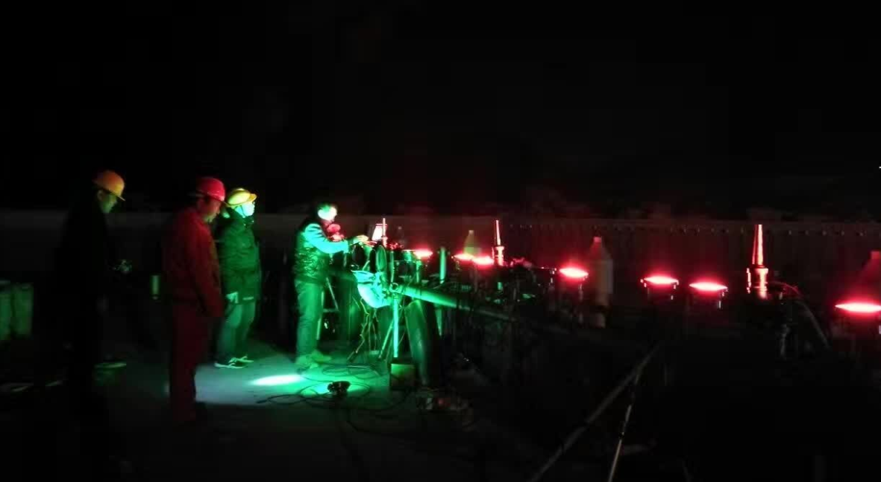

Engineers with client on site
